**R Code for Examples in the book**

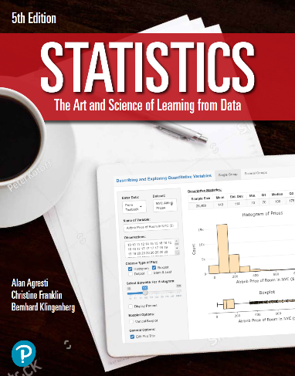

***“Statistics: The Art and Science of Learning from Data”***

**by Agresti, Franklin and Klingenberg, 5th edition**

**Chapter 12**

**Example 15: Maximum Bench Press – Confidence and Prediction Intervals**

## Reading in data

athletes <- read.csv(file='https://raw.githubusercontent.com/artofstat/data/master/Chapter12/highschool_female_athletes.csv')  
colnames(athletes) #check column names

## [1] "Athlete" "BP60" "maxBP..lbs."   
## [4] "LP200" "maxLP..lbs." "Situps..per.minute."  
## [7] "X40YD..sec." "VerticalJump..in." "SitReach..in."   
## [10] "MB..in." "SR..sec." "Age"   
## [13] "Height..in." "Weight..lbs." "Bodyfat...."   
## [16] "BMI" "Sport"

## Fitting regression model

linReg <- lm(maxBP..lbs. ~ BP60, data = athletes)  
summary(linReg)

##   
## Call:  
## lm(formula = maxBP..lbs. ~ BP60, data = athletes)  
##   
## Residuals:  
## Min 1Q Median 3Q Max   
## -17.9205 -5.9027 -0.7237 5.4989 19.0973   
##   
## Coefficients:  
## Estimate Std. Error t value Pr(>|t|)   
## (Intercept) 63.5369 1.9565 32.475 < 2e-16 ***  
## BP60 1.4911 0.1497 9.958 6.48e-14 ***  
## ---  
## Signif. codes: 0 '***' 0.001 '**' 0.01 '*' 0.05 '.' 0.1 ' ' 1  
##   
## Residual standard error: 8.003 on 55 degrees of freedom  
## Multiple R-squared: 0.6432, Adjusted R-squared: 0.6368   
## F-statistic: 99.17 on 1 and 55 DF, p-value: 6.481e-14

## To find a 95% confidence for the population mean for x = 11

predict(linReg, newdata = data.frame(BP60 = 11),   
 interval='confidence', se.fit = TRUE)

## $fit  
## fit lwr upr  
## 1 79.93844 77.81405 82.06283  
##   
## $se.fit  
## [1] 1.060051  
##   
## $df  
## [1] 55  
##   
## $residual.scale  
## [1] 8.003188

## To find a 95% prediction interval for a single observation of x = 11

predict(linReg, newdata = data.frame(BP60 = 11),   
 interval='prediction')

## fit lwr upr  
## 1 79.93844 63.75961 96.11727